**PROJECT REPORT TEMPLATE**

1 INTRODUCTION

* 1. Overview

Administrator should be able to create all base data including semester candidate, course and lecturer, lecturer should have the ability to create internal results, Dean, who is one of the Lecturer, should be the only one with ability to update internal Results, Revaluation Can be Candidate for all Internal Results. Now only dean can update the marks after re-evaluation.

1.2 Purpose

Recruitment CRM (candidate relationship management) is a software system that manages the entire recruitment process while building and maintaining relationships with job candidates.

* Engage with candidates on a deeper level
* Build flexible and dynamic career pages

**2 Problem Definition & Design Thinking**

2.1 Empathy Map

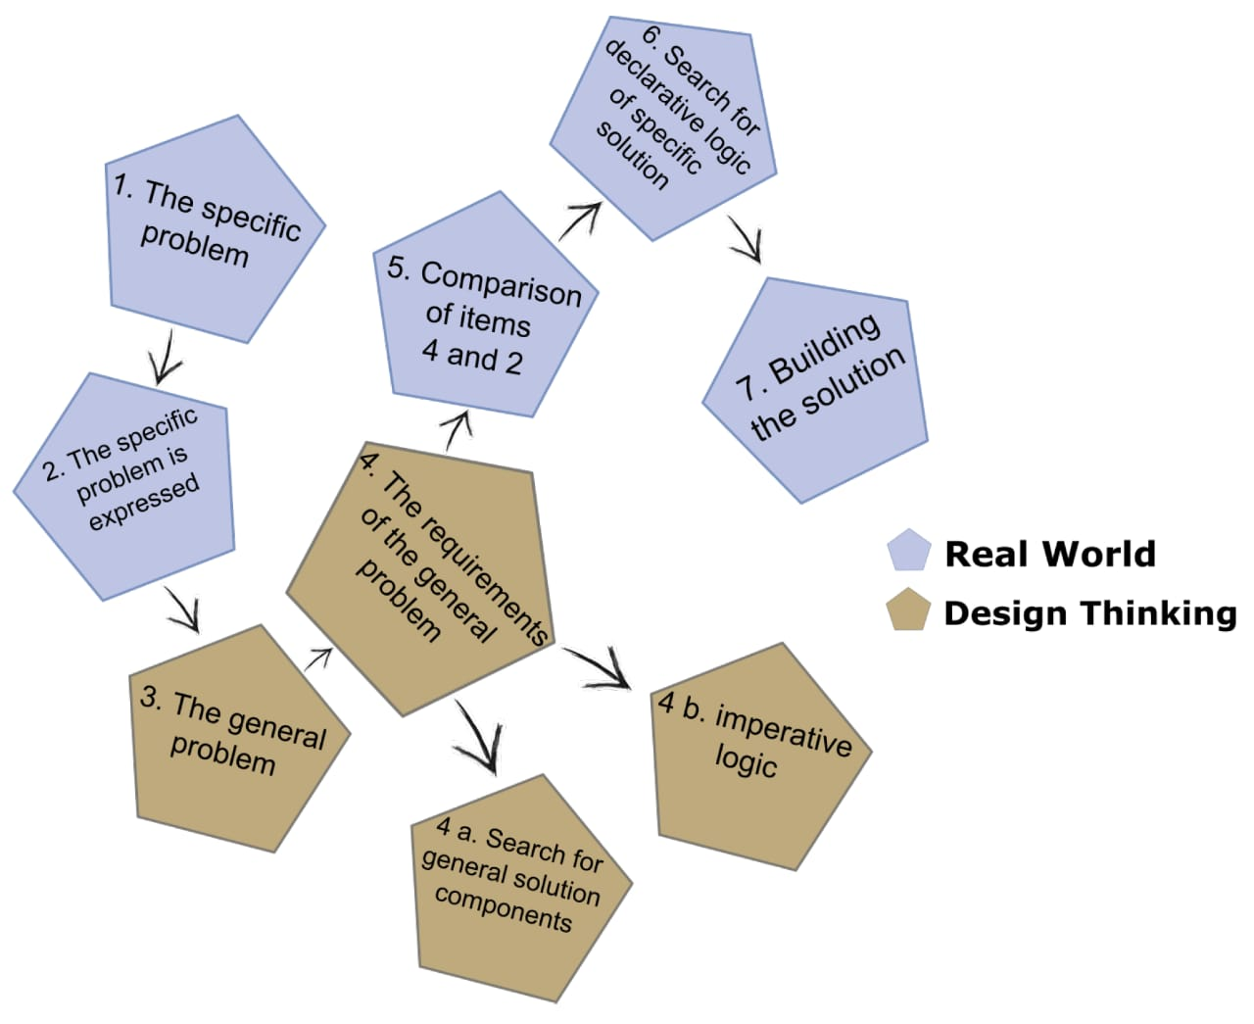

2.2 Ideation & Brainstorming Map

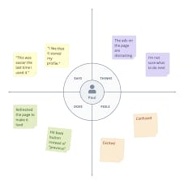

3 RESULT

* 1. Data Model:

|  |  |
| --- | --- |
| **Object name** | **Fields in the Object** |
| obj1 | |  |  | | --- | --- | | Field label | Data type | | CANDIDATE ,COURSE DETAILS , LECTURER, INTERNAL RESULTS | text | |  |  | |

**Activity & Screenshot**

1. 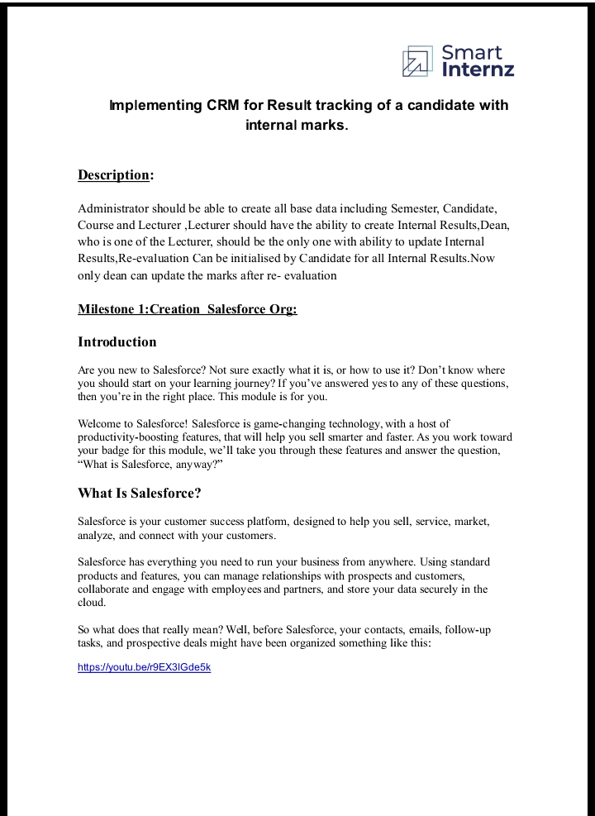
2. 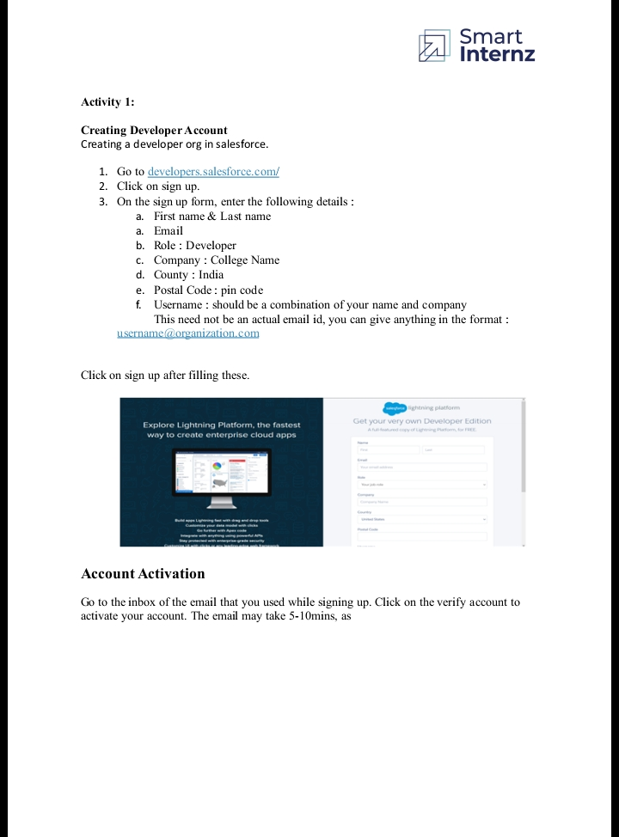
3. 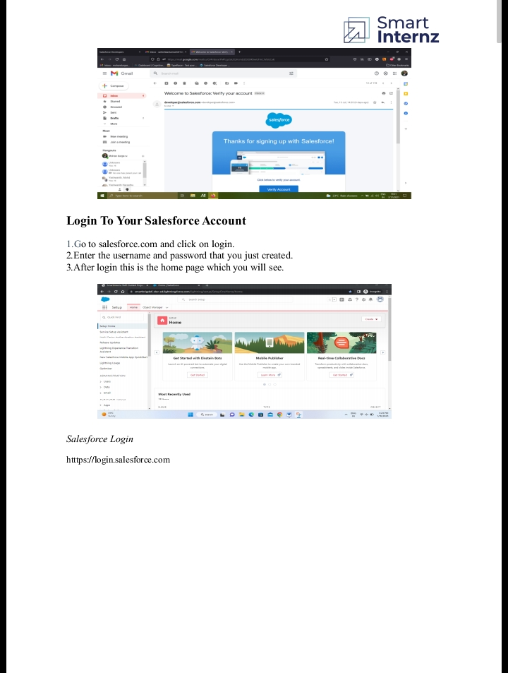
4. 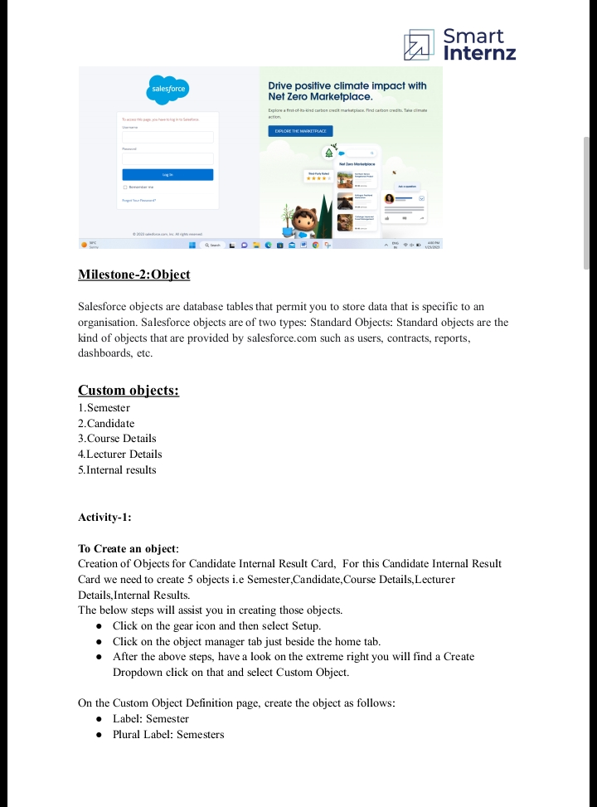
5. 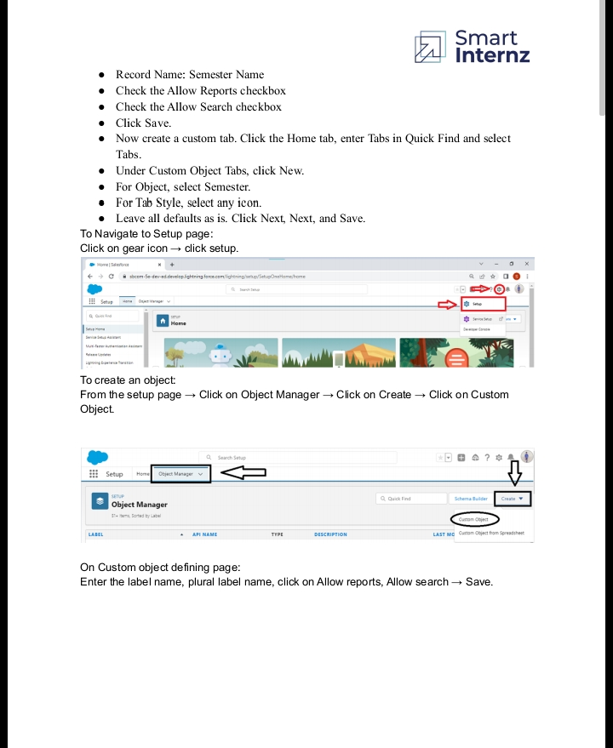
6. 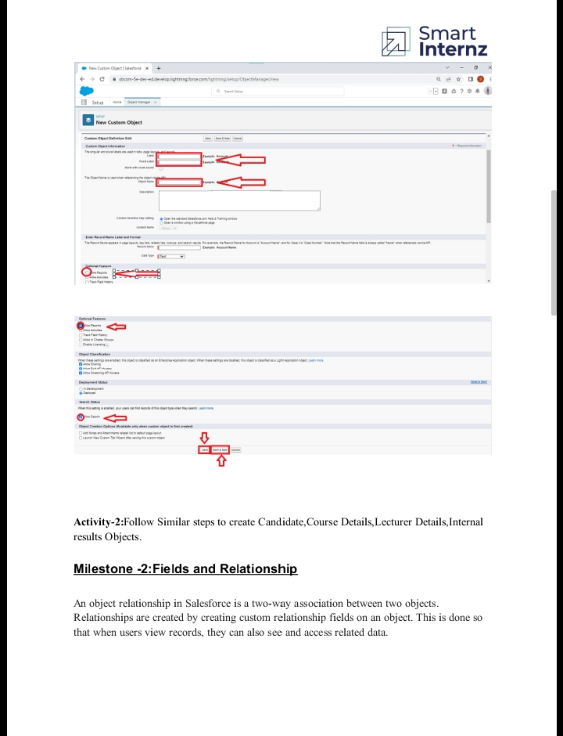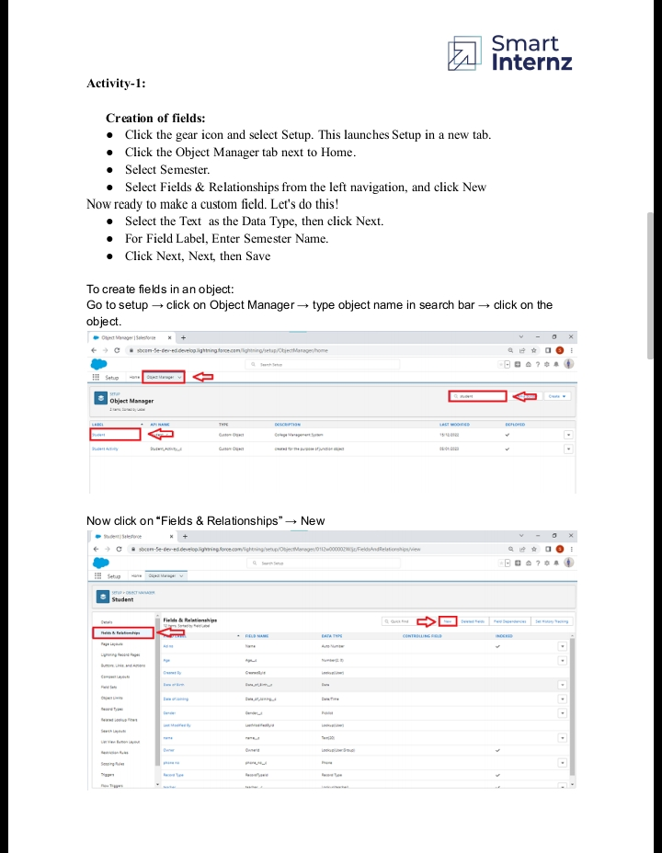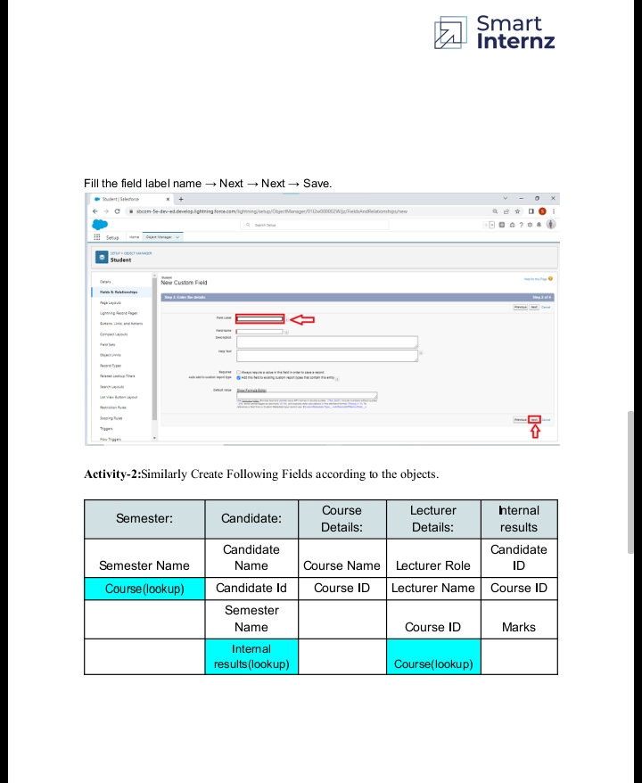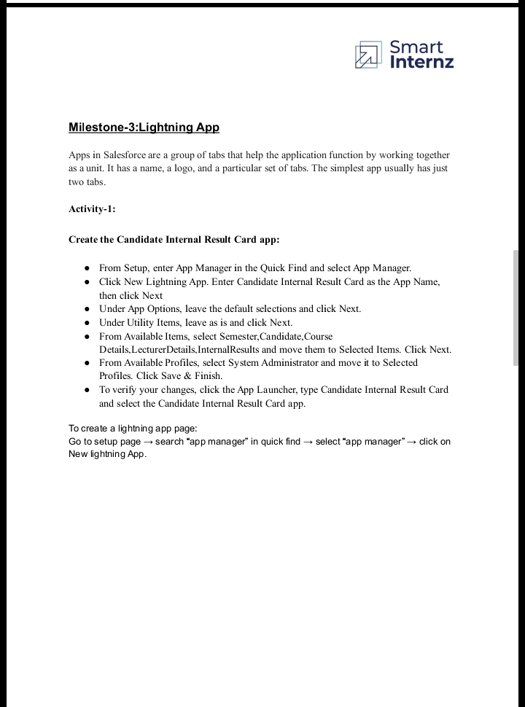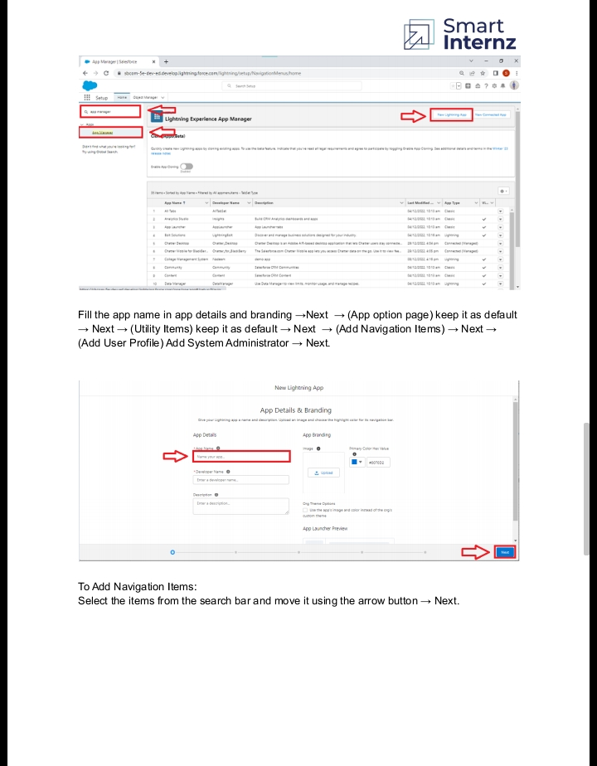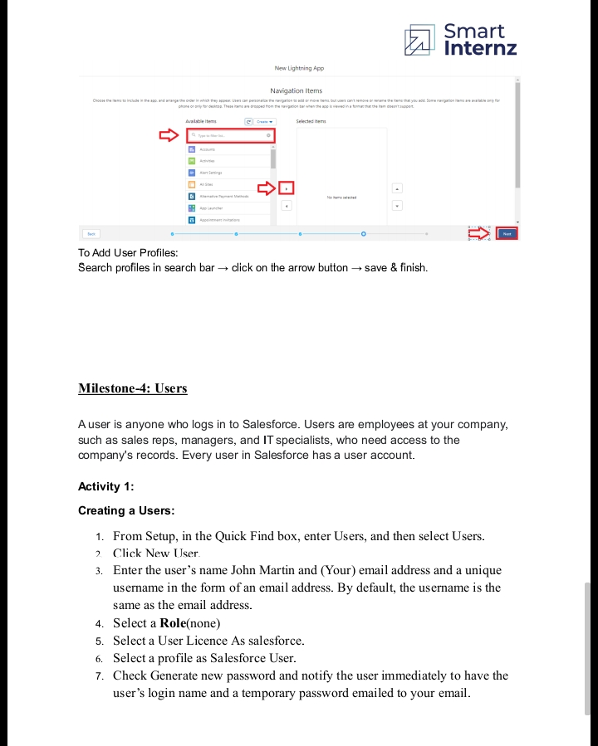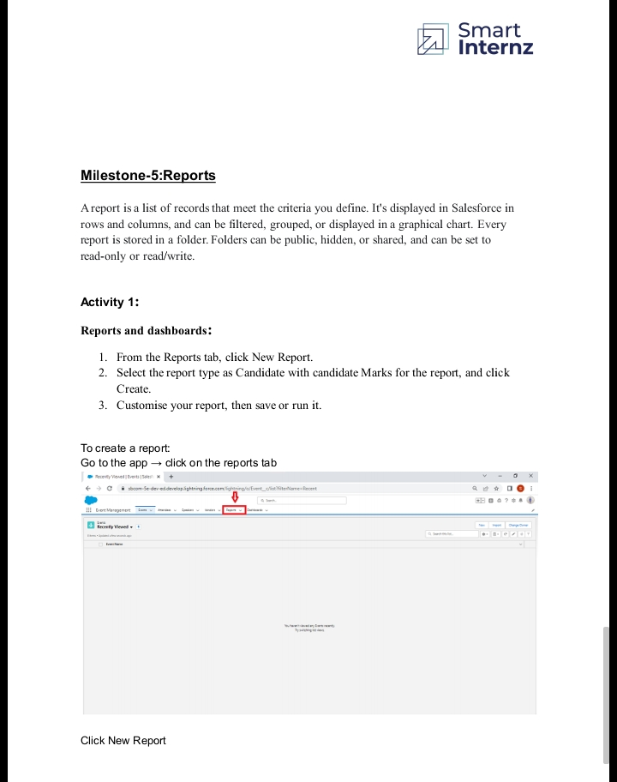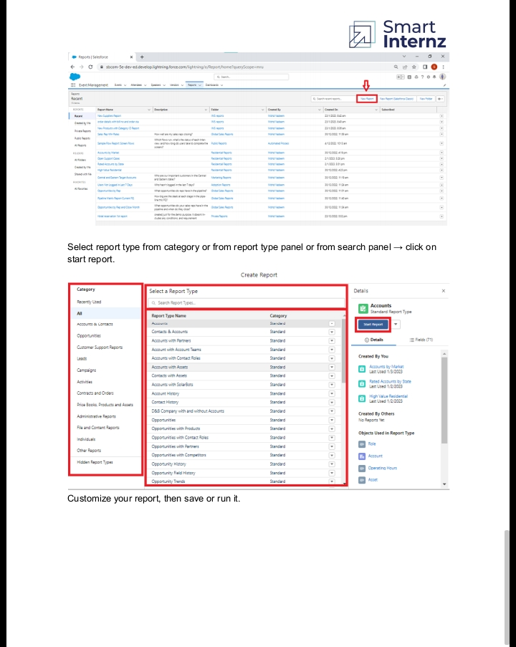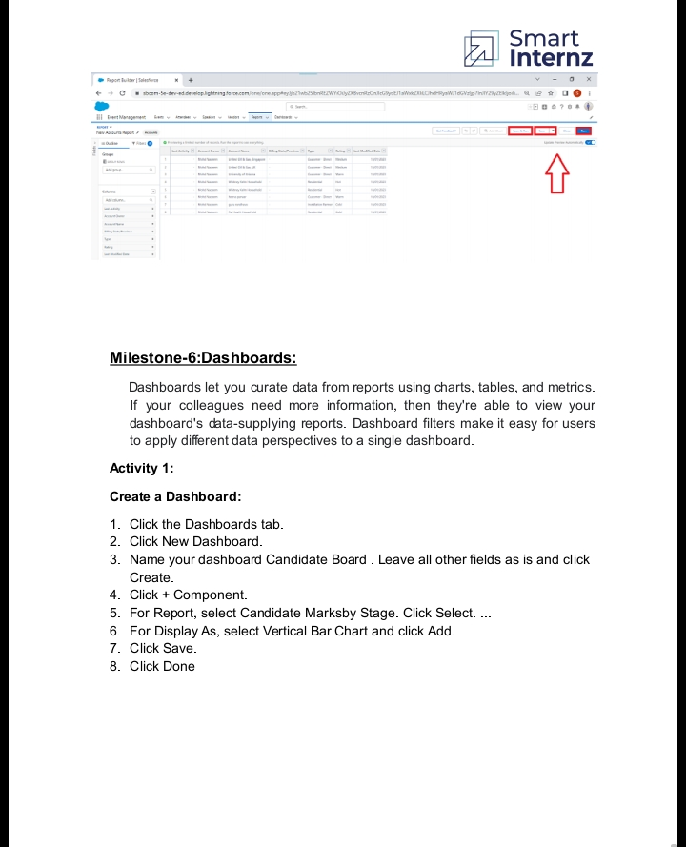**Trailhead Profile Public URL**

**Team Lead** [**https://trailblazer.me/id/sivas297**](https://trailblazer.me/id/sivas297)

**Team Member 1** [**https://trailblazer.me/id/sthennarasu**](https://trailblazer.me/id/sthennarasu)

**Team Member 2** [**https://trailblazer.me/id/sivas296**](https://trailblazer.me/id/sivas296)

**Team Member 3 –** <https://trailblazer.me/id/sentigram>

**Team Member 4 -https://trailblazer.me/id/vinos37**

1. **ADVANTAGES**

The advantages of a business using a CRM system greatly outweigh the disadvantages. However, there are pitfalls. For a CRM system to work, there needs to be buy-in across the organisation and the processes in place to support it. Otherwise, your CRM may end up being an expensive waste of time. Here, we take a look at the strategic pros, cons, and importance of CRM.

1. **DISADVANTAGE**

We’ve looked at the pros—the advantages—of initiating a **CRM system**, so now it’s time to examine some of the cons—the disadvantages—of a CRM system. Whilst ultimately these are fewer in number than the advantages, for some businesses, the short-term pain of a cultural and technological shift can be a lot to bear and may not generate a return.

1. **APPLICATIONS**

**candidate** Scoring. Lnkdin Extension. Drag & Drop Pipeline. Task Automation. Collaboration. AI Recruitment ATS & **CRM** for Recruiters. All-In One Platform To Manage Hiring Process. No Credit Card Required. Start Today.

1. **CONCLUSION**

Project manager (leader)

Systems developer (installation)

Data analyst (data migration)

QA engineer (testing)

Champions (representatives)

1. **FUTURE SCOPE**

To not throw your time and money down the drain, you need to prepare and implement your CRM system right. And if your organization has many disparate systems, data sources, and complex processes, you may need to use professional , to ensure that all the data and workflows are mapped right. But in case you want to launch CRM rollout on your own, follow the guidelines below to guarantee project success.